2025 TERM 1 MZIMBA NORTH DISTRICT EXAMINATIONS

MATHEMATICS FORM 4

PAPER II
(100 MARKS)
10th Dec. 2025
SUBJECT NUMBER: M131/II
TIME ALLOWED: 2 HOURS 30 MINUTES
INSTRUCTIONS

- This paper has 16 pages. Please check.
- The maximum number of marks for each answer is indicated against each question.
- Write your answers in the spaces provided
- Calculators may be used and all working should be clearly shown.
- Please make sure that you write your examination number and class on top of all pages in this paper before you start answering questions.

Questions  Answered | Tick if  Answered | Do not write in this column
1
2
3
4
5
6
7
8
9
10
11
12
Total

©MZN-1-2025
Turn over

SECTION A (60 MARKS)
Answer all the six questions in this section
- . Express $1-\frac{1}{X}-\frac{X-2}{X-1}$ as a single fraction in its simplest form. (5 marks)

b. Without using a calculator, simplify $\frac{2\sqrt{3}}{\sqrt{2}(\sqrt{5}+1)},$giving the answer with rational denominator. (5 marks)

- Given that if $g\left(t\right)=at^{2}+bt-3.$ $g\left(2\right)=4$ and $g\left(-2\right)=6.$ Find a and b.
(6 marks)

b. Given that $μ=\left\{1, 3, 6, 7, 9, 15, 17, 18, 19, 22, 24\right\}, M=\left\{3, 15, 18, 19\right\}, N=\left\{1, 6, 7, 18, 24\right\}$ and $P=\left\{3, 6, 15, 19, 24\right\}.$ Find $M∪N^{'}∩P$ (4 marks)

- Using a ruler a pair of compasses only, construct in the same diagram
- a circle centre 0 of 3cm
- a tanget TZ I to the circle at Z such that OT=5cm
- in the same diagram, measure and state the length of ZT
(5 marks)

b. make p the subject of the formula $y=3\log_{a}{(p^{2}+5)}$ (4 marks)

- If $P=\left[\begin{matrix}2 & 4 \\ 0 & -1\end{matrix}\right]$ and $Q=\left[\begin{matrix}-4 & 2 \\ 3 & 1\end{matrix}\right]$, calculate $PQ-\frac{1}{2}P$ (5 marks)

b. Solve the equation ${2x}^{2}-5x+1=0$ giving your answer correct to two decimal places
(6 marks)

- On the graph below, draw the region which satisfy the following inequalities
$3x+4y≤12$, $2y<3x+6,$ $x<4 and y≥0$ (6 marks)
,
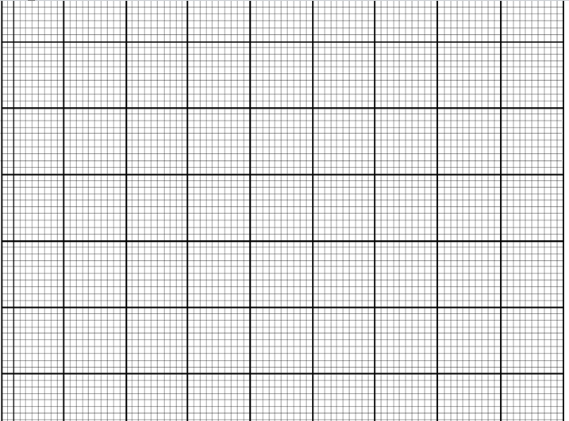

b. The line joining points $A\left(P, 4\right), B(5-P, 8)$ has a gradient of $\frac{1}{2}$. Calculate the
value of P. (4 marks)

- A point T has the coordinates$\left(\begin{matrix}3 \\ 2\end{matrix}\right)$. The matrix which transforms T into $T^{'}$ is $\left[\begin{matrix}2 & 0 \\ 1 & 1\end{matrix}\right]$. Calculate the coordinates of $T^{'}$ (5 marks)

b. If the $4^{th}$ and $7^{th}$ term of a geometric progression (GP) are 4 and 32 respectively, calculate the first term (5 marks)

SECTION B (40 marks)
Answer any four questions.
- Find the standard deviation for the set data whose deviations from the mean are $-2, -3, 4, 1$ (4 marks)

b. A chord of a circle of radius 5cm is 8cm long. Sketch the diagram and calculate the angle subtended by the chord at the centre of the circle (6 marks)

8. A cyclist starts from rest and accelerates uniformly for 4 minutes to reach a speed of 300 metres/minutes. She then maintains this speed for 6 minutes after which she decelerates uniformly for 5 minutes to come to a complete stop. Using a scale of 2 cm to represent 50 metres/minutes in the vertical axis and 2 cm to represent 2 minutes in the horizontal axis, draw a speed-time graph for the cyclist on the graph paper provided. (10 marks)
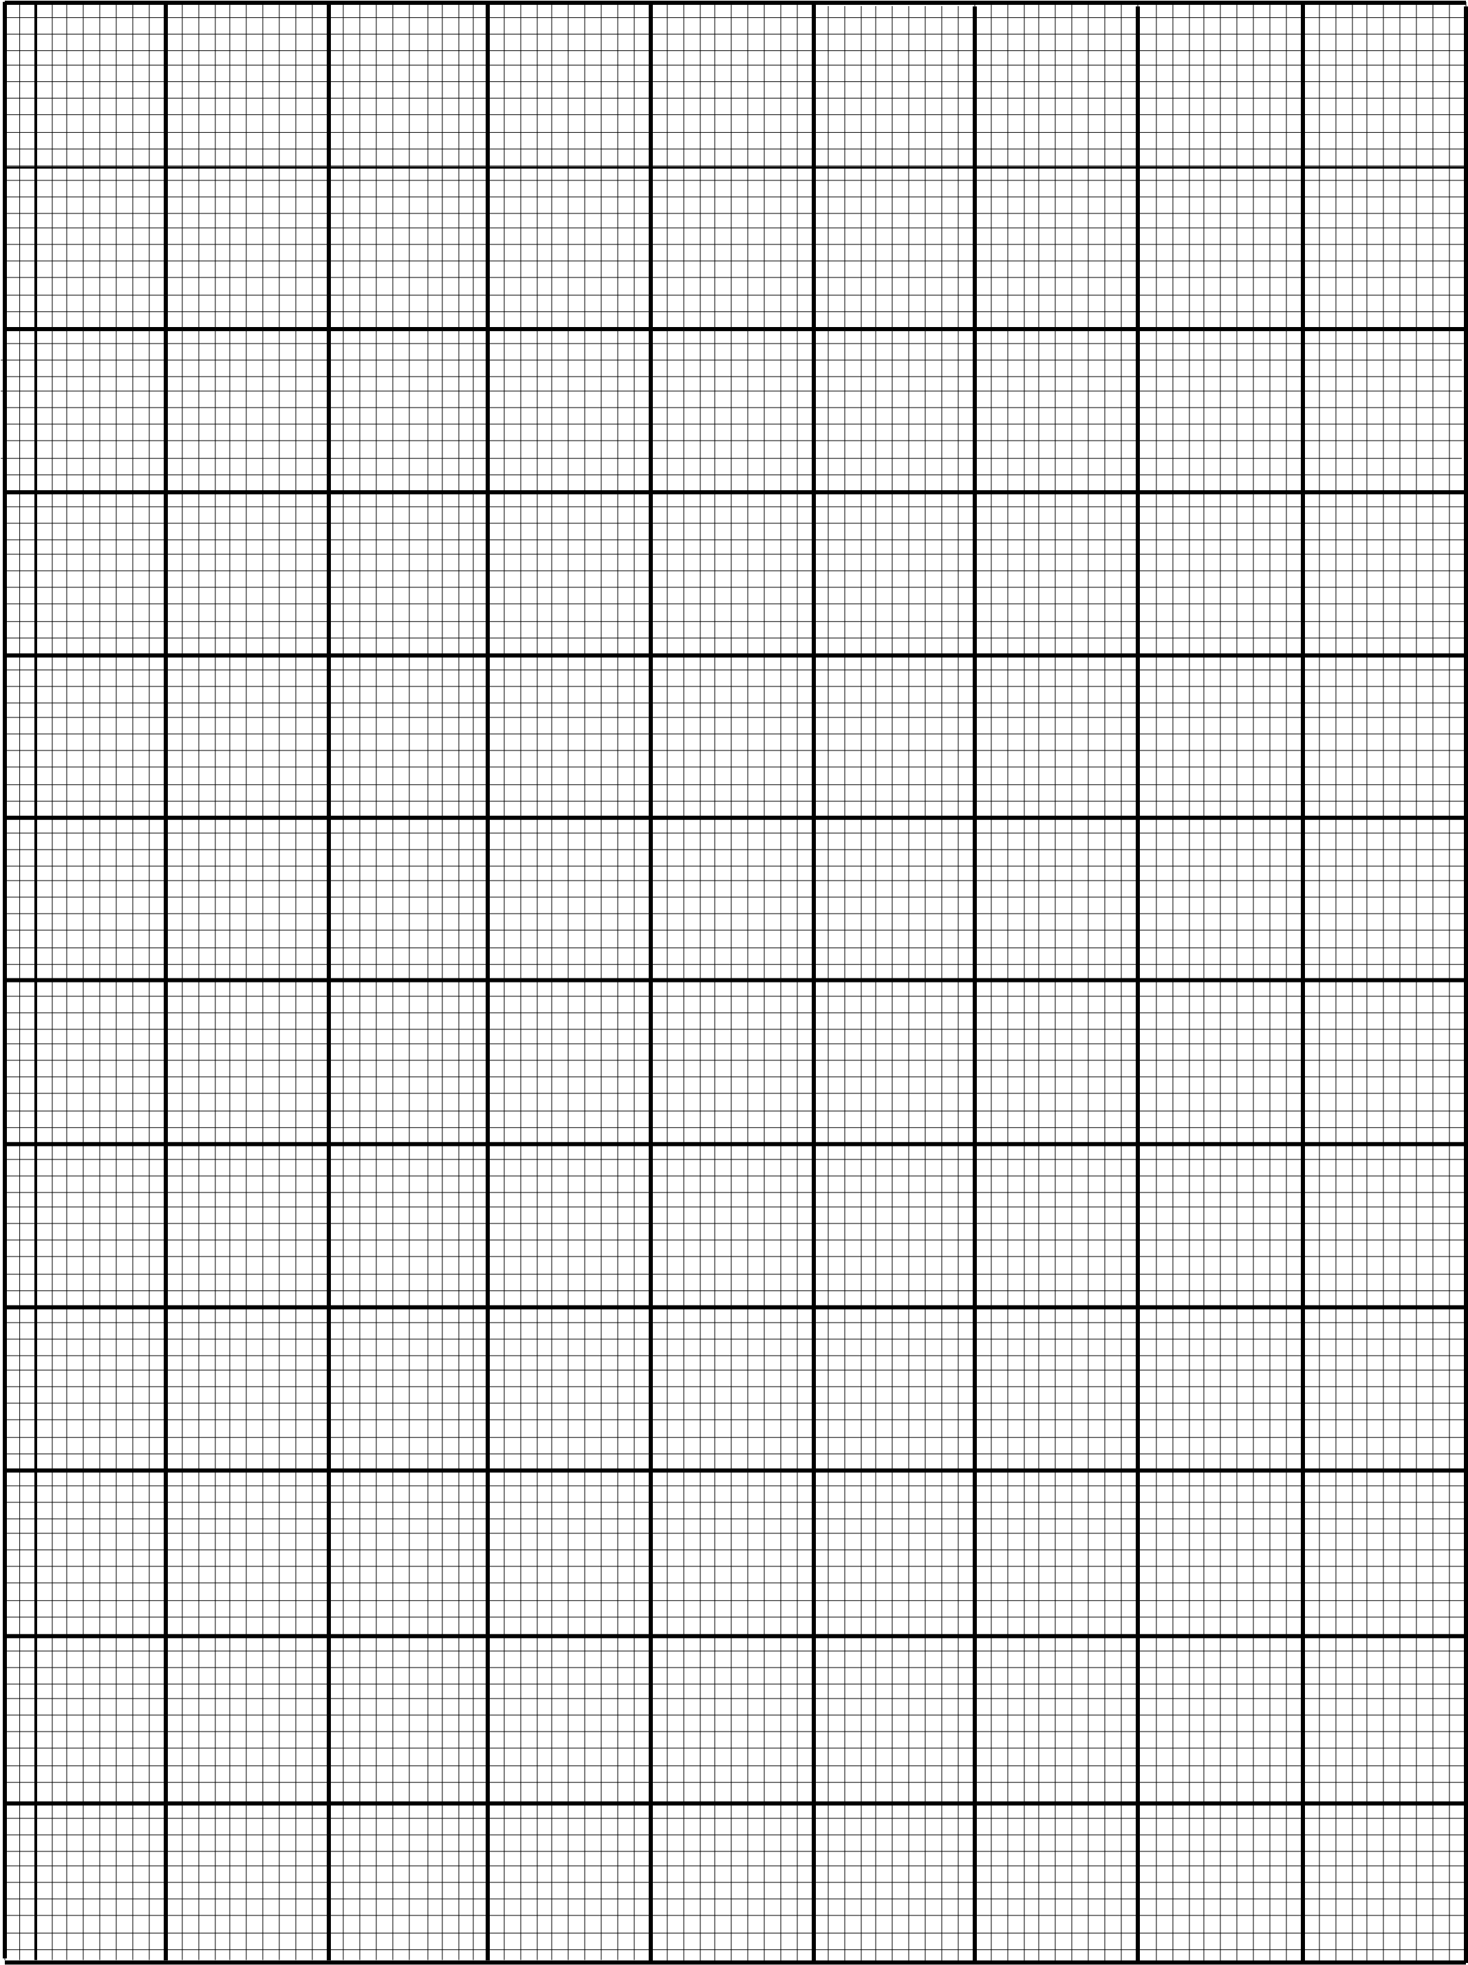
9. Solve the simultaneous equations
$x^{2}-y-5=0$
$\frac{1}{2}y-x=-1$ (10 marks)

10. The cost (C) for an international call from Malawi to Europe, partly varies inversely as time, (t), and partly as the square of the time. A one minute call costs K120 and a two minute call costs K200. Find the cost of a five-minutes time call (10 marks)

11. a. Solve for x if ${(2^{x})}^{2}-9\left(2^{x}\right)+8=0$ (6 marks)

b. Given that the roots of a quadratic equation $y=x^{2}+ax+b$ are -3 and 2, find the values of a and b in the equation (4 marks)

12. Copy and complete the following table which shows a set of values of x and y that satisfy the equation y=$x^{2}+x-2$.
x | -4 | -3 | -2 | -1 | 0 | 1
y | 10 |  |  | -2 | -2 | 0

              - Copy and complete the table
              - Taking a scale of 2cm to represent 2 unit on the y-axis axis and 2cm to represent 1 unit on the x-axis, draw the graph of $y=x^{2}+x-2$
              - Use your graph to find the minimum value of y. (10 marks)





END OF QUESTION PAPER

